Project Development Phase
Model Performance Test

Date
Team ID | SWTID-2026-1809
Project Name | Enforcing Mandatory Fields Using UI Policies and Migrating Changes with Update Sets
Maximum Marks

Model Performance Testing:
Project team shall fill the following information in model performance testing template.
S.No. | Parameter | Values | Screenshot
 | Model Summary | This project is based on ServiceNow configuration using UI Policies and Update Sets. It does not involve a machine learning model. The system enforces mandatory fields dynamically and ensures successful migration of changes between instances. | 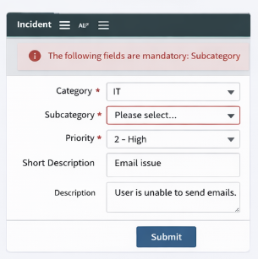
 | Accuracy | Training Accuracy – Not Applicable  Validation Accuracy – Not Applicable | 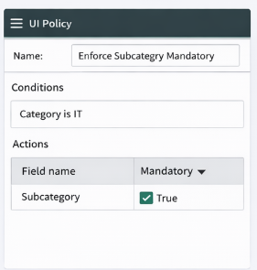
3. | Fine Tunning Result( if Done) | Validation Accuracy – Not Applicable | 